Gain = 2.775
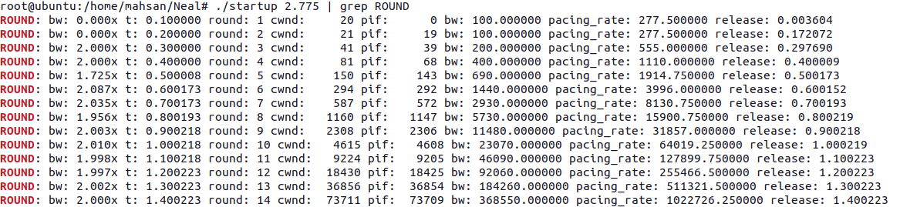

Gain=2.774

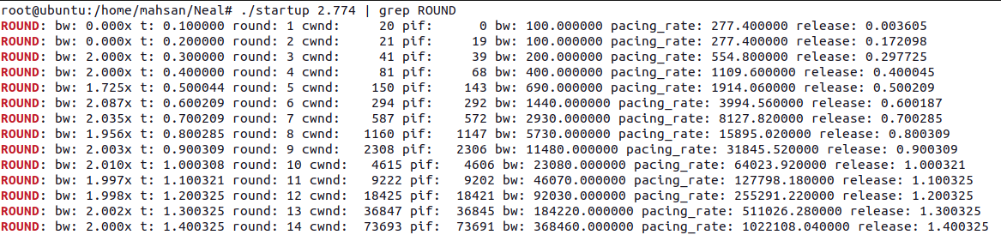
Gain=2.773
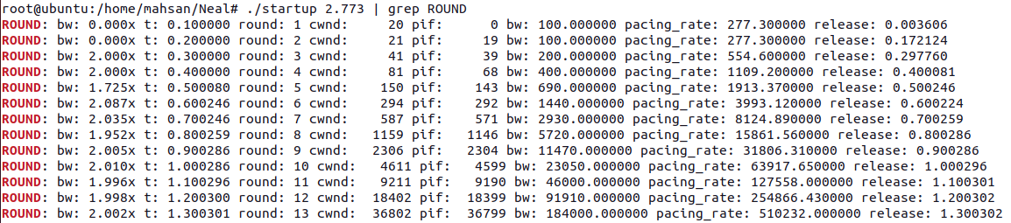

Gain=2.773 till round 15.
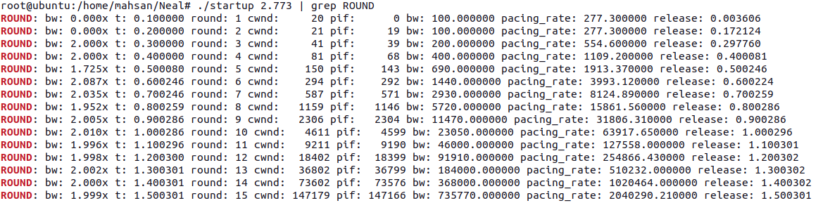

Now Gain=2.8
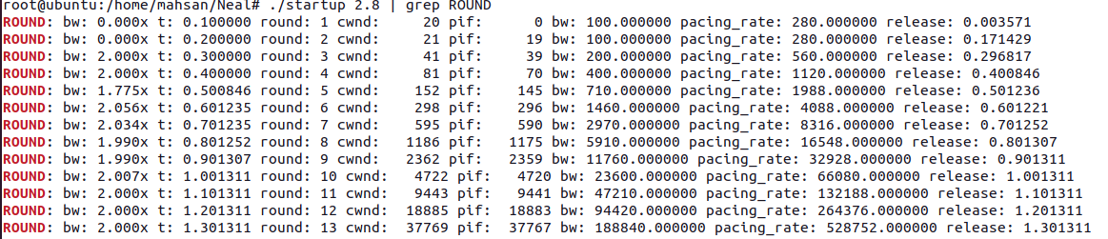
Gain:2.88
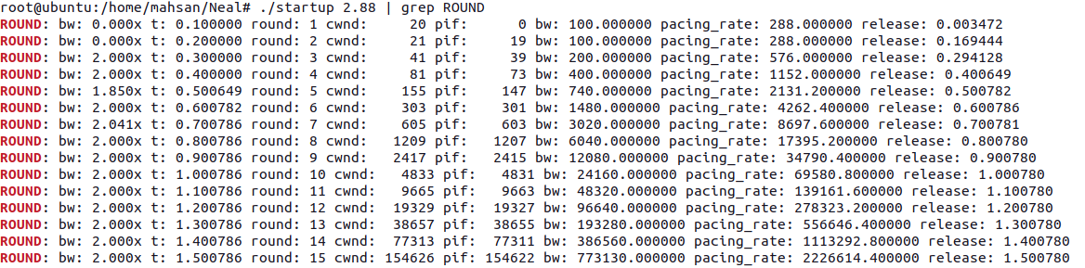
Gain:2.885

